EF Core 8.0
Lab 1: Understanding ORM with a Retail Inventory System
Scenario:
You’re building an inventory management system for a retail store. The store wants to track products, categories, and stock levels in a SQL Server database.
Objective:
Understand what ORM is and how EF Core helps bridge the gap between C# objects and relational tables.

Steps:
1. What is ORM?
• Explain how ORM maps C# classes to database tables.

Ans: ORM establishes a relationship between C# classes and database tables by following a mapping mechanism.
- Each C# class represents a database table.
- Each property of the class represents a column in that table.
- Each object (instance) of the class represents a row (record) in the table.
- The primary key of the table is represented by a property such as Id or ProductId.
- Relationships between classes (such as one-to-many or many-to-many) are mapped to relationships between database tables using foreign keys.

• Benefits: Productivity, maintainability, and abstraction from SQL.
Productivity: Reduces development time by allowing developers to perform database operations using C# objects instead of writing SQL queries.
Maintainability: Makes applications easier to update and maintain by managing database changes through C# models and migrations.
Abstraction from SQL: Hides complex SQL syntax by automatically converting C# code into SQL queries, allowing developers to focus on application logic.

2. EF Core vs EF Framework:
• EF Core is cross-platform, lightweight, and supports modern features like
LINQ, async queries, and compiled queries.
• EF Framework (EF6) is Windows-only and more mature but less flexible.
3. EF Core 8.0 Features:
• JSON column mapping.
• Improved performance with compiled models.
• Interceptors and better bulk operations.
4. Create a .NET Console App:
dotnet new console -n RetailInventory
cd RetailInventory
5. Install EF Core Packages:
dotnet add package Microsoft.EntityFrameworkCore.SqlServer
dotnet add package Microsoft.EntityFrameworkCore.Design

Solution:-
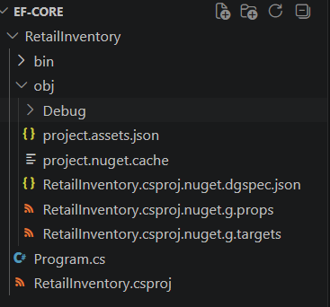

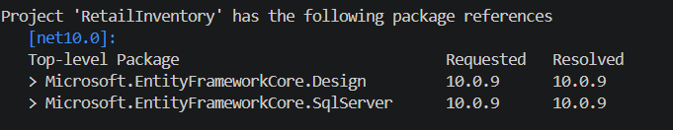

Lab 2: Setting Up the Database Context for a Retail Store
Scenario:
The retail store wants to store product and category data in SQL Server.
Objective:
Configure DbContext and connect to SQL Server.
Steps:
1. Create Models:
public class Category {
public int Id { get; set; }
public string Name { get; set; }
public List Products { get; set; }
}
public class Product {
public int Id { get; set; }
public string Name { get; set; }
public decimal Price { get; set; }
public int CategoryId { get; set; }
public Category Category { get; set; }
}
2. Create AppDbContext:
public class AppDbContext : DbContext {
public DbSet Products { get; set; }
public DbSet Categories { get; set; }
protected override void OnConfiguring(DbContextOptionsBuilder optionsBuild
er) {
optionsBuilder.UseSqlServer("Your_Connection_String_Here");
}
}
3. Add Connection String in appsettings.json (optional for ASP.NET Core).
Solution:-
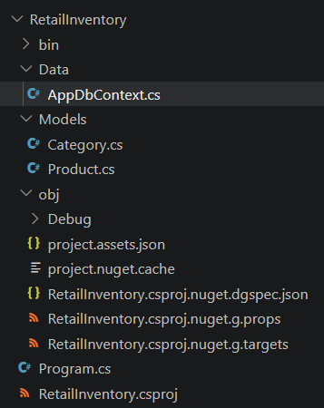

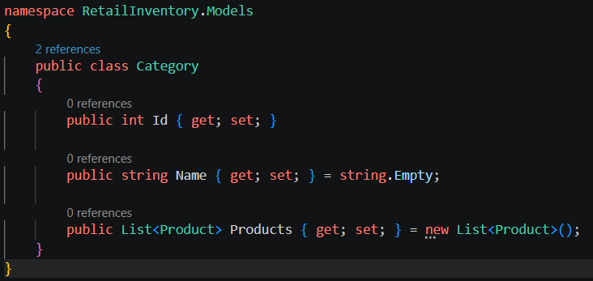
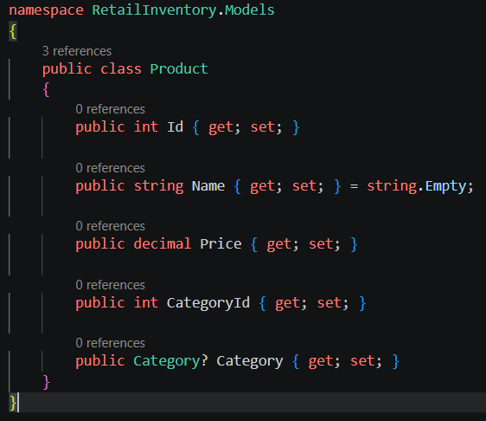

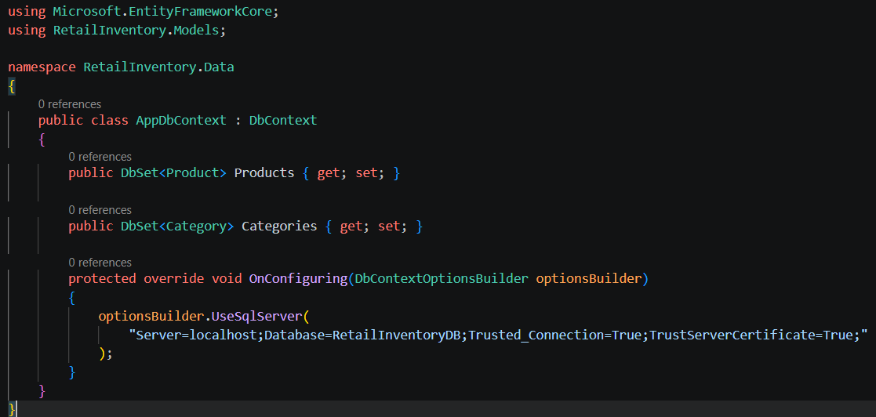

Lab 3: Using EF Core CLI to Create and Apply Migrations
Scenario:
The retail store's database needs to be created based on the models you've defined.
You’ll use EF Core CLI to generate and apply migrations.
Objective:
Learn how to use EF Core CLI to manage database schema changes.
Steps:
1. Install EF Core CLI (if not already):
dotnet tool install --global dotnet-ef
2. Create Initial Migration:
dotnet ef migrations add InitialCreate
This generates a Migrations folder with code that represents the schema.
3. Apply Migration to Create Database:
dotnet ef database update
4. Verify in SQL Server:
Open SQL Server Management Studio (SSMS) or Azure Data Studio and confirm
that tables Products and Categories are created.

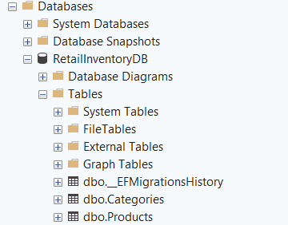

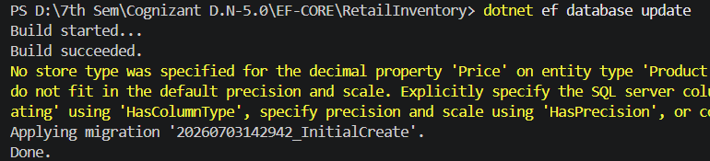
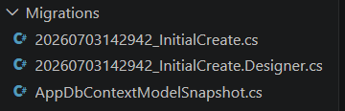
Lab 4: Inserting Initial Data into the Database
Scenario:
The store manager wants to add initial product categories and products to the system.
Objective:
Use EF Core to insert records using AddAsync and SaveChangesAsync.
Steps:
1. Insert Data in Program.cs:
using var context = new AppDbContext();
var electronics = new Category { Name = "Electronics" };
var groceries = new Category { Name = "Groceries" };
await context.Categories.AddRangeAsync(electronics, groceries);
var product1 = new Product { Name = "Laptop", Price = 75000, Category = electro
nics };
var product2 = new Product { Name = "Rice Bag", Price = 1200, Category = groceri
es };
await context.Products.AddRangeAsync(product1, product2);
await context.SaveChangesAsync();
2. Run the App:
dotnet run
3. Verify in SQL Server:
Check that the data is inserted correctly.
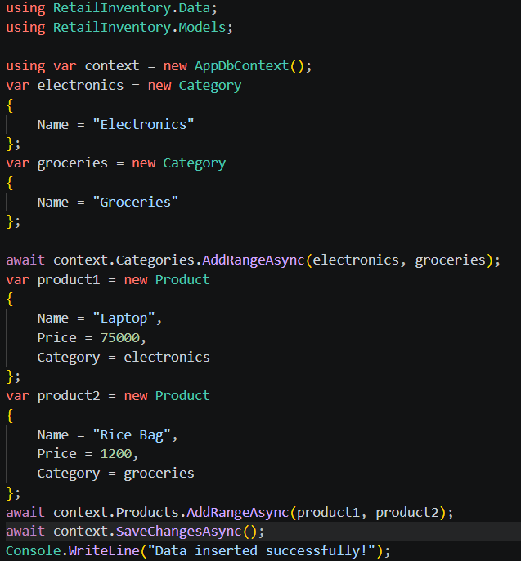

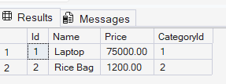

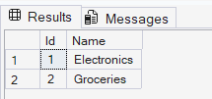

Lab 5: Retrieving Data from the Database
Scenario:
The store wants to display product details on the dashboard.
Objective:
Use Find, FirstOrDefault, and ToListAsync to retrieve data.
Steps:
1. Retrieve All Products:
var products = await context.Products.ToListAsync();
foreach (var p in products)
Console.WriteLine($"{p.Name} - ₹{p.Price}");

2. Find by ID:
var product = await context.Products.FindAsync(1);
Console.WriteLine($"Found: {product?.Name}");

3. FirstOrDefault with Condition:
var expensive = await context.Products.FirstOrDefaultAsync(p => p.Price > 50000);
Console.WriteLine($"Expensive: {expensive?.Name}");

Solution:-
